**Aditya Jangra (200434215)**

**Why I choose this topic.**

The Aim of this College Website Project in ASP.Net Mvc is to implement the website for the college the purpose of this website project is to provide the clarified information about college to the users (Students, Parents, and Anonymous users) through website and provide the information about college as well as their students. This project was developed under ASP.Net MVC & C#.Net Programming language using Visual studio and SQL Server 2008 r2 used for storing the data.

**Developer Responsibilities**

Understanding the industry necessities from basic level and convert into solutions.

Created database using SQL Server 2008 R2.

Implementation of Front End Using ASP.NET& C#.Net under Visual Studio.

Uphold the relation Between Frontend and Backend Using ADO.NET

### Abstraction

### Abstraction alludes to the demonstration of speaking to basic highlights without including the backend subtleties or clarifications. Classes utilize the idea of abstraction and are characterized as a rundown of abstract attributes.

### Encapsulation

Encapsulation conceal the useful details of a class as of objects that send messages to it.

### Polymorphism

Polymorphism permits the software engineer to treat determined class individuals simply like their parent class' individuals. All the more definitely, Polymorphism in object-situated writing computer programs is the capacity of items having a place with various information types to react to calls of techniques for a similar name, every one as indicated by a fitting kind explicit conduct. One strategy, or an administrator, for example, +, - , or *, can be uniquely applied in a wide range of circumstances. On the off chance that a Pup is told to talk (), this may inspire a bark (). Not with standing, if a Pig is instructed to talk (), this may evoke an oink (). Every subclass abrogates the talk () strategy acquired from the parent class Creature.

**What is E-R(enityrealtionship) Diagram ?**

An entity relationship diagram (ERD) shows the connections of substance sets put away in an information base. ER Diagrams are frequently used to plan or debug relational database sets in the fields of programming designing, business data frameworks, instruction and researh.

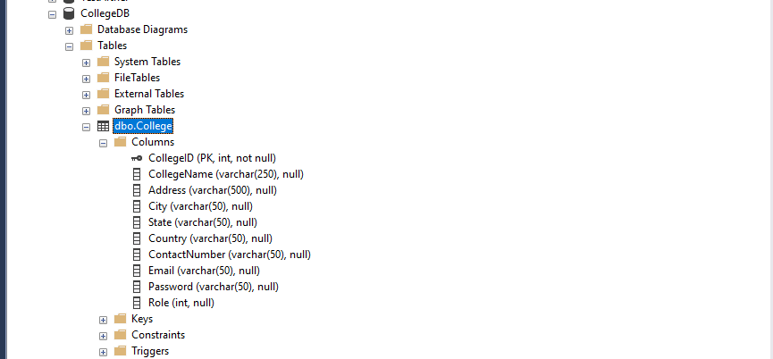

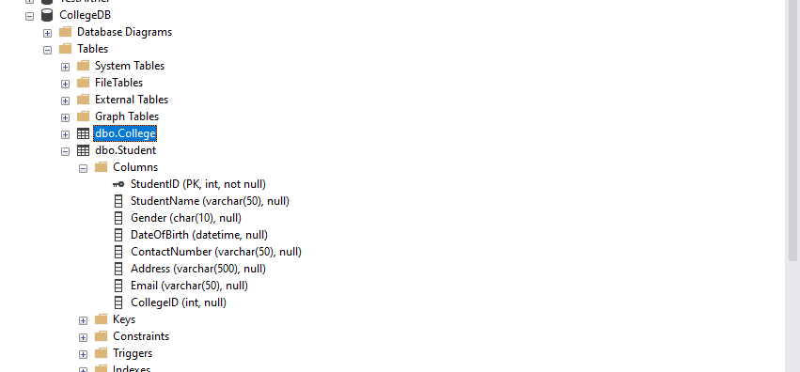

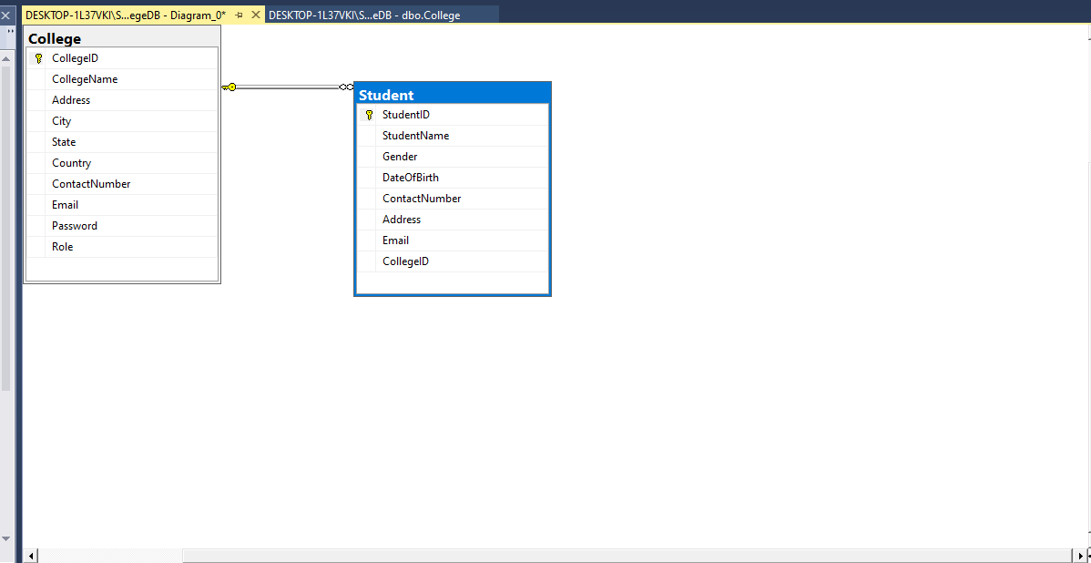

**One-to-one**

When just one case of an entity is connected with the bond, it is marked as '1:1'. In one-to-one connection each one entity should be associated with the bond.

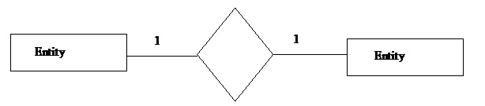

**One-to-many**

When more than one case of an entity is connected in a bond, it is termed as '1:N'. In one-to-many bond each entity on the left and more than one case of an entity on the right can be connected with the bond.



About the Website

1. Home page



1. Colleges Attached with is site as well as their students

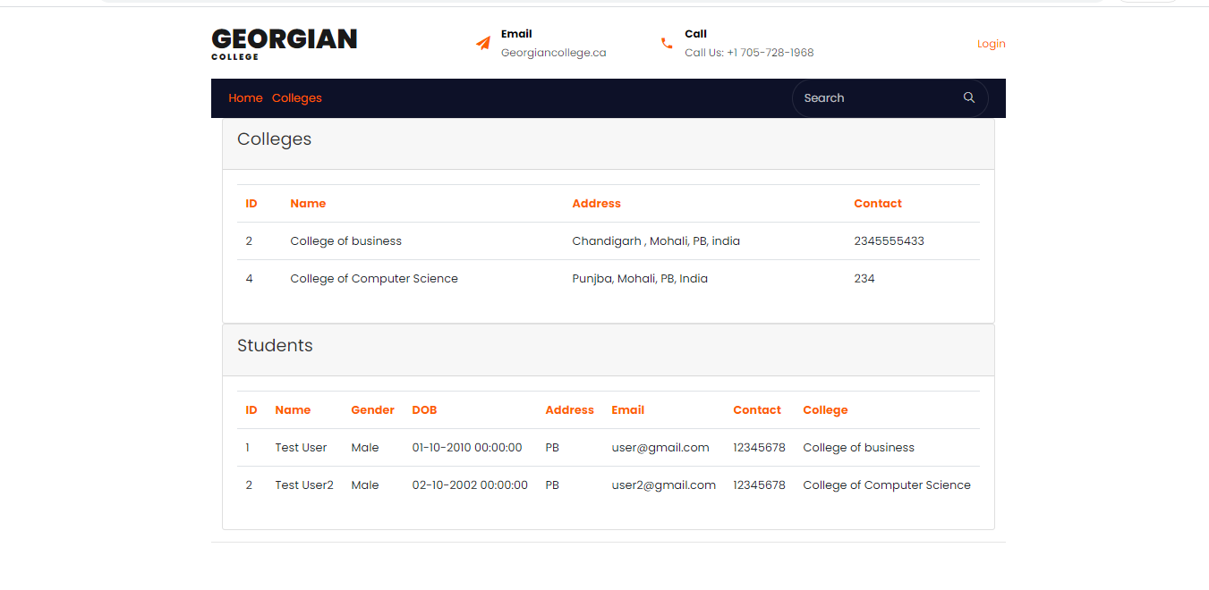

1. Admin panel

All college List in admin panel

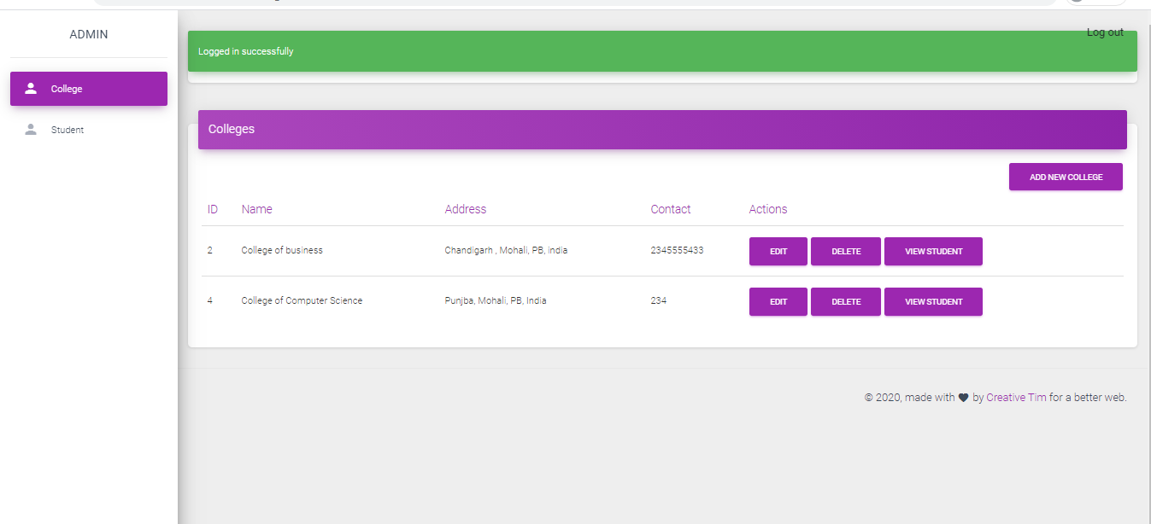

1. All students List

